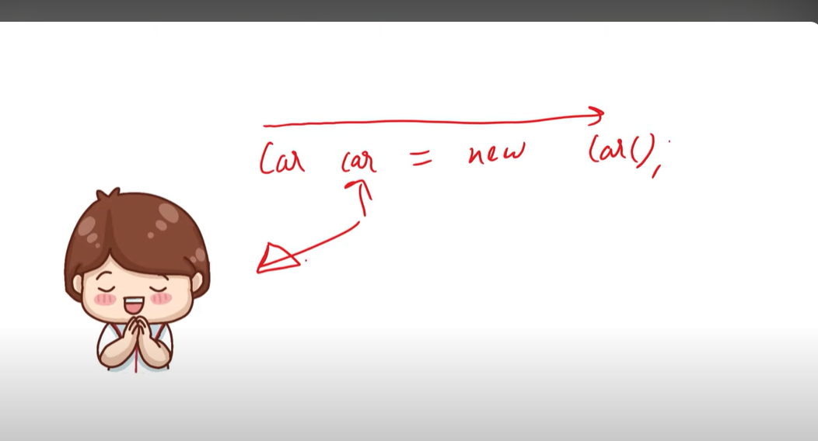

We are creating object by ourself. Now, we are saying that someone else create object for us

This is called inversion of control -> We’re handling someone to create object for us

Now, we’’ll use IOC containers to initialize the spring objects.

It will have all classes in it and we will ask IOC container to create objects for us.

Application Context is a way to implement IOC container.

A CONTAINER HAVING CLASSES, A BOX HAVING CLASSES

It scans classes inside the package and it keeps only special classes.

If any class has **@Component** on it then it will keep it.

Now what is **annotation**?

It can be written on class, function, field, methods, interface.

It provide information according to component.

Bean 🡪 Object

IOC takes only those classes that are beans

**@Component** makes bean, write it on class and this class will be inside the IOC container.

We can use it directly.

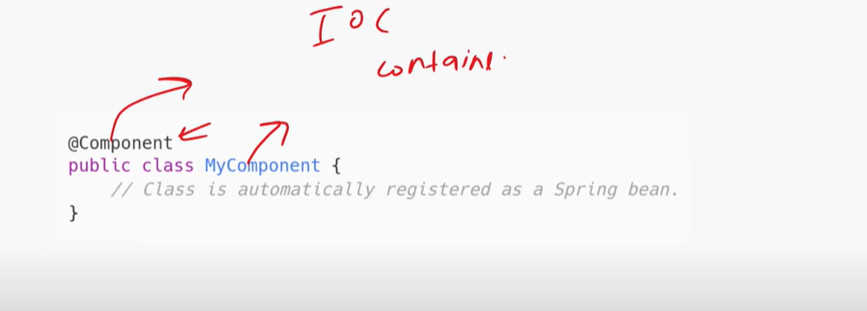

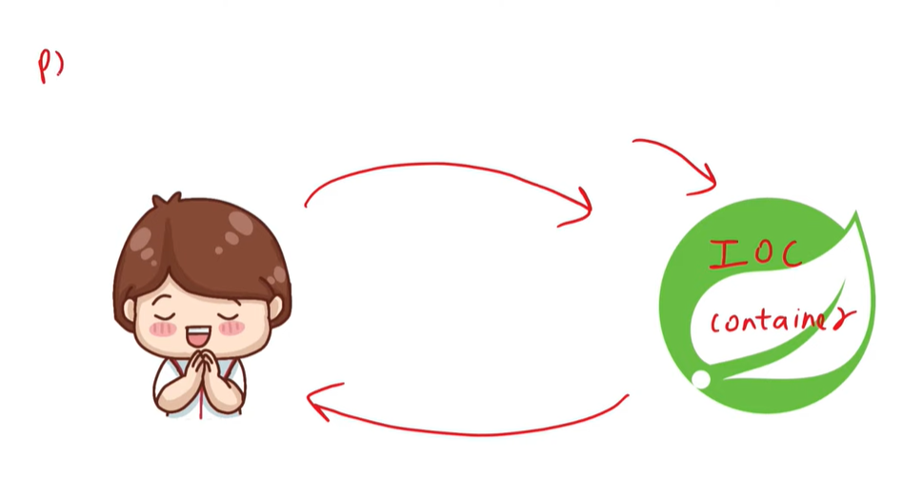

**@SpringBootApplication**

We apply only at main class where our main method is written.

This annotation does three tasks for us listed below

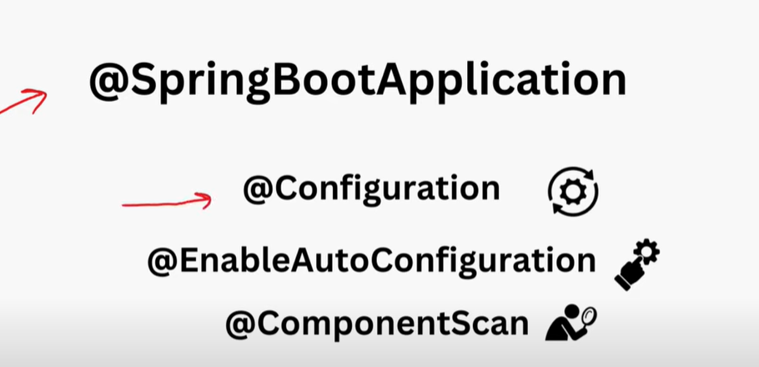

**@Component scan** searches for beans -> objects so that if user demands then provide it to user.